*CJFAS Article*

**Habitat Heterogeneity and Phenotypic Variation: Site Temperature Largely Predicts Diverse Spawning Portfolios of an Interior Chinook Salmon Stock**

Author order to be determined

Russell F. Thurow1* (ORCID iD: 0000-0002-1362-8599)

Bryan M. Maitland2 (ORCID iD: 0000-0002-4491-5064)

Morgan M. Sparks2 (ORCID iD: 0000-0003-0787-2218)

Daniel J. Isaak2 (ORCID iD: 0000-0003-2963-1546)

John M. Buffington2 (ORCID iD: 0000-0002-2513-5863)

1*US Forest Service, Rocky Mountain Research Station (Emeritus), Salmon, ID, USA 83467*

2*US Forest Service- Rocky Mountain Research Station, 322 East Front St.- Suite 401, Boise, Idaho, USA 83702.*

\**Corresponding author (e-mail: [russ.thurow@usda.gov](mailto:russ.thurow@usda.gov))*

**Abstract**

Spawning phenology strongly influences population resilience and local adaptation in Pacific salmon, yet the environmental mechanisms structuring this diversity remain incompletely understood. We analyzed 3,016 georeferenced redds collected from eight tributaries of Idaho’s Middle Fork Salmon River between 2002 and 2005 to evaluate how thermal and geomorphic conditions influence Chinook Salmon (*Oncorhynchus tshawytscha*) spawn timing. Linear mixed-effects models with stream-reach random intercepts and temperature-specific random slopes explained nearly all observed variation in spawning day-of-year (conditional R² = 0.985). Spawn timing increased nonlinearly with antecedent 90-day mean temperature at respective spawning reaches, plateauing at warmer sites. Stream and year effects were also significant, with spawning occurring progressively later through time. Random slopes revealed pronounced reach-scale heterogeneity in thermal sensitivity, indicating that local hydrologic and geomorphic processes mediate phenological responses to temperature. Together, these results demonstrate that stream level and fine-scale habitat heterogeneity sustains diverse spawning portfolios even within a single interior Chinook population, providing critical adaptive capacity to changing environments.

**Keywords**

Spawn timing, portfolio effect, biocomplexity, life history diversity, phenotypic plasticity

**Introduction**

Pacific Salmon populations exhibit extraordinary life history diversity, shaped by complex and heterogeneous environments across their range (Brannon et al. 2004). The enormous diversity of salmon life history traits (Waples et al. 2004) evolved in response to spatiotemporal variation in both biotic and abiotic conditions (Stearns 1976), and acts to reduce risks of demographic failure by buffering populations against environmental change and exploitation (Hilborn et al. 2003, Greene et al. 2009; Schindler et al. 2010; Beamish 2016). Chinook salmon (*Oncorhynchus tshawyscha*) display an especially diverse demographic portfolio characterized by a broad array of phenotypes, including variation in age and timing of seaward migration, duration of freshwater and marine residence, ocean distribution, age and season of spawning migration, and timing of spawning (Healey 1991).

Among these traits, spawning phenology has important ecological and evolutionary consequences. The timing of adult migration and spawning can shape reproductive isolation among temporally segregated groups and lead to fine-scale local adaptation (Manhard et al. 2017). While run timing (entry into freshwater) is often used to define populations segments (Brannon et al. 2004, Waples et al. 2004), here we focus on spawn timing (the date when adults deposit fertilized eggs in gravel), as a fine-scale expression of phenotypic variation. Spawn timing varies within and across salmon populations and has a well-documented genetic component (Ricker 1972; Quinn et al. 2002; Beulke et al. 2023). For example, high site fidelity and limited straying spatially segregates related individuals on spawning grounds and leads to fine-scale genetic structuring (Neville et al. 2006). Spatial heterogeneity in habitat conditions can promote this diversity by selecting for locally adapted phenologies (Ruff et al. 2011).

Temperature strongly influences salmonid spawn timing (Hendenon 1963; Morrison and Smith 1986; Beechie et al. 2008). Because embryonic development rates are mechanistically driven by ambient temperature (Sparks et al. 2025), salmon tend to spawn at times that ultimately synchronize fry emergence with conditions that optimize offspring growth and development (Quinn 2018; though see Sparks et al. 2019). Several studies have linked site-specific thermal regimes to observed variation in spawning phenology (Sheridan 1962; Burger et al. 1985; Heggberget 1988; Lisi et al. 2013). However, although the importance of temperature as a determinant of spawn timing is well established, the underlying landscape features that may drive thermal variation (i.e., physiography, geomorphology, and hydrology), are poorly understood (Montgomery 1999; O’Sullivan et al. 2019). Geomorphic attributes including slope, elevation, confinement, and groundwater connectivity can shape reach-scale thermal regimes, thereby constraining or enabling different spawning strategies (Beechie et al. 2006, 2008; Jonsson and Jonsson 2011). Lisi et al. (2013), for example, demonstrated that variation in watershed slope, elevation, and lake area explained a large proportion of summer stream temperature and sockeye spawn timing in Alaskan streams, highlighting geomorphology’s indirect but powerful role in structuring phenological diversity.

The Middle Fork Salmon River (Middle Fork) supports one of the most intensively monitored Chinook salmon populations in the Columbia River Basin. Long-term redd surveys by state, federal, and tribal agencies provide a uniquely rich dataset for examining environmental drivers of spawning phenology. The Middle Fork supports wild, indigenous Chinook salmon populations unaltered by direct hatchery supplementation (Thurow et al. 2019) and the watershed is managed as a designated wild anadromous fish sanctuary (IDFG 2019). Minimal anthropogenic effects and a geographic size that facilitates natural processes (i.e., wildfire, floods, debris flows, and snow avalanches) ensure generation and maintenance of diverse environmental conditions (Isaak et al. 2003; Thurow 2015). These natural processes function relatively unimpeded by humans because of the Wilderness status of the lands encompassing the watershed. As a result, natal habitats remain diverse, high quality, and connected, and exotic fishes are relatively uncommon (Thurow 2000; Isaak and Thurow 2006; Thurow 2015).

Leveraging this unique system and dataset, we examined how variation in stream temperature and local habitats influence Chinook salmon spawn timing across multiple years in several Middle Fork tributaries. Characterizing variation in natural processes within stream networks and understanding how spatial and temporal variability in physical processes and Pacific salmon interact is critical for establishing recovery targets (Bisson et al. 2009) and for evaluating population persistence under changing environmental conditions (Isaak et al. 2018). Our objectives were to: 1)compile stream reach-scale physical attributes and Chinook salmon spawning phenology from 2002 to 2005, 2) summarize variation in spawn timing across four years in eight streams, and 3) fit a series of linear mixed-effects models to identify associations among environmental covariates and spawn timing.

**Methods**

***Study Area***

The Middle Fork drains ~7,330 km2 of terrain, predominantly within the Frank Church River of No Return Wilderness, and is one of eight original National Wild and Scenic Rivers designated in 1968 (Figure 1; NWSRS 2016). From its headwaters the Middle Fork flows 171 km before joining the Salmon River near Salmon, Idaho (USFS 1998; Minshall et al. 1981; Thurow 2000; Thurow et al. 2019). Approximately 800 km of mainstem and tributary habitat are accessible to Chinook salmon (Mallet 1974; Thurow 1985). Detailed study area information can be found in Minshall et al. (1981), Thurow (2000), Servheen et al. (2001), and Thurow et al. (2019).

Adult Chinook salmon migrate from the Pacific Ocean up the Columbia and Snake rivers to spawn in the Middle Fork, typically arriving in early summer and spawning from late July to mid-September. Salmon in this system express a stream-type life history, with most juveniles rearing for one year in freshwater before outmigration (Healey 1991). However, fish exhibit multiple freshwater (age 0-2) and saltwater (1-5) ages, in addition to non-migrating precocial males (Gebhards 1960; James et al. 1998; Copeland and Venditti 2009). Observations suggest that early-arriving adults tend to spawn at higher elevations and later arrivals spawn progressively lower in the basin (Fulton 1968; Gebhards 1959; IDFG 1992; Parkhurst 1950).

Despite the Middle Fork’s quality of connected habitats that are sustained by natural processes, Chinook salmon abundance in the system has severely declined. Current populations average 1-3% of salmon numbers that annually returned in the mid-1960s (Thurow et al. 2019). Altered migration corridors are considered a proximate cause of salmon declines in recent decades (Jacobs et al. 2022). Nonetheless, the watershed supports some of the most intact and connected natal habitat remaining in the Columbia River Basin.

***Reach selection, Chinook salmon redd counts, and spawn timing***

From 2001-2005, we selected study reaches in six major salmon spawning tributaries (Big, Bear Valley, Camas, Loon, Marsh, and Sulphur Creeks) to encompass a range of variation in elevation, stream size, and spawn timing. To support collaboration and improve efficiency, some study reaches overlapped with existing index reaches monitored annually by the Idaho Department of Fish and Game (IDFG), the Nez Perce or Shoshone-Bannock tribes, or the U.S. Forest Service (see Thurow et al. 2019 for index reach methods and locations). Spawning occurs across a broad elevation range, from < 920 m in the lower mainstem to > 2000 m in tributary headwaters. After selecting reaches, surveyors designated and marked subsections where redds would be identified.

Surveyors intensively monitored Chinook salmon spawning from the onset of redd construction through the completion of spawning. From late July through mid-September, trained observers walked stream banks within each study reach every 3-4 days and searched for newly constructed redds. Observers began surveys before the onset of spawning and georeferenced redd locations with GPS units. To avoid commission errors during the initial survey, observers recorded all prior year redds or redd-like streambed features that might have been confused with new redds.

Based on our prior observations in the Salmon River basin, female Chinook salmon typically remain on excavated redds for 3-5 days. Consequently, we assumed our 3-5 day survey interval maximized the likelihood of detecting all redds soon after their construction.

Considering surveys were completed every 3-4 days, we inferred spawn timing from the first date a redd was recorded as fully constructed. Redd locations were spatially joined to stream reaches in the NHDPlus dataset (Moore et al. 2019) and assigned a common identifier (COMID). This identifier was used to link each redd with environmental covariates from the corresponding stream reach (i.e., COMID). C (Marsh Creek tributaries) because ofThe final dataset contained 3,016 georeferenced redds (*i.e.*, inferred spawn date) across 104 stream reaches (i.e., COMIDs), nested within six major spawning tributaries that also included Beaver Creek (tributary to Marsh Creek) and Elk Creek (tributary to Bear Valley Creek) to total eight different spawning streams, and spanning four years.

***Covariates***

To identify environmental predictors of spawn timing, we linked each redd location to stream temperature, discharge, elevation, and slope at the stream reach scale (COMID). Covariates were selected based on ecological relevance, full coverage across the study area, and low collinearity (Appendix A1, Section 1.2). Elevation and slope were obtained from NHDPlus (Moore et al. 2019). We indexed thermal conditions using modeled daily stream temperatures at the COMID level from Siegel et al. (2023), and confirmed strong agreement with temperature logger data recorded in Idaho (Figure A1.7). Stream discharge data were drawn from a single USGS gage (13309220) near the basin outlet. For each redd, we calculated sequential time-windowed summaries of temperature and flow—i.e., 30-, 60-, and 90-day averages prior to, during, and following the inferred spawn date.

Initially, we established the appropriate modeling framework using exploratory data analysis and visualizations to evaluate variation in spawn timing across years and streams, examine bivariate relationships between spawn date and continuous covariates, and assess pairwise correlations among predictors (Appendix A2). Based on these results, we retained 90-day antecedent temperature as a focal thermal covariate; post-spawn and fixed-date summaries were more weakly associated with spawn timing and showed higher collinearity. Elevation exhibited a weak association with spawn timing and was retained for its ecological interpretability, while slope was uncorrelated but provisionally retained. Although 90-day antecedent streamflow was initially considered, we excluded it because of its poor spatial resolution, strong collinearity with year, and limited ecological relevance at the reach scale.

***Data analysis***

We used linear mixed-effects models to evaluate environmental predictors of Chinook salmon spawn timing, with redd observation day-of-year as the response variable. Continuous covariates were scaled (mean = 0, SD = 1) to aid convergence and interpretation of models. All models included a random intercept for `COMID` to account for repeated measures across stream reaches. Further, based on exploratory analysis and biological expectations of nonlinear thermal responses, temperature effects were modeled using both linear and quadratic terms for the 90-day average stream temperature prior to spawning (temp_90).

We fit 31 additive models representing all combinations of fixed effects (temp_90, stream, year, slope, and mean elevation; Appendix A3.1). Candidate models were fit using maximum likelihood to allow direct comparison across differing fixed-effect structures. We also tested whether model performance improved by allowing the effect of temperature to vary across stream reaches via adding a random slope for 90-day antecedent temperature term to the COMID grouping factor. This random slope model was fit with restricted maximum likelihood (REML) and compared to the simpler random intercept model. To determine whether the quadratic 90-day antecedent temperature term remained necessary with random slopes, we re-fit the model with and without the quadratic effect using maximum likelihood. Finally, we evaluated whether additional fixed-effect interactions improved model performance by adding interaction terms between 90-day antecedent temperature and either stream or year.

**Results**

***Spawn timing variation in space and time***

Across all streams and years, Chinook salmon spawning exhibited a broadly unimodal distribution, with most activity concentrated between mid-August and early September (Figure 2A). The global mean spawn date was day 240 (August 28th), although year-specific means varied by nearly three weeks (Figure 2A). Stream-level spawning distributions revealed additional spatial structure (Figure 2B), with some streams (e.g., Bear Valley and Beaver creeks) exhibiting narrower peaks, while others (e.g., Big and Camas creeks) displayed broader or later distributions. Year effects were also evident (Figure 2C), with 2005 skewed later than preceding years.

When examined jointly by stream and year, density curves illustrated that each stream expressed a characteristic spawn timing “signature”; although the strength and consistency of this signature varied (Figures A1.3-1.4). Some streams (e.g., Beaver and Marsh creeks) displayed sharp, highly synchronous peaks, whereas others (e.g., Big, Camas, and Elk creeks) exhibited broader, more heterogeneous distributions. These stream-level differences were nested within year effects, reinforcing the combined influence of space and time on diverse spawning phenology.

The cumulative proportion of redds (Figure 3) provided an intuitive view of the pace and duration of spawning. Streams such as Marsh and Sulphur creeks exhibited rapid increases, suggesting short, concentrated spawning intervals. In contrast, Big and Camas creeks illustrated more gradual redd accumulations, indicative of extended spawning seasons. Interannual variability was also evident, with some streams shifting substantially across years. Together, these patterns highlight the pronounced spatial and temporal heterogeneity in Chinook salmon spawn timing across the Middle Fork watershed.

***Model comparison***

We used AIC-based model selection to identify parsimonious models explaining spatial and temporal variation in spawn timing. Model comparisons identified stream identity, interannual variation, and nonlinear temperature responses as the strongest predictors of Chinook salmon spawn timing, while topographic variables contributed less consistently (Table 1). Model m26 had the lowest AIC among the candidate models, yet predicted later spawning at higher elevations which is counter to raw data patterns (Figure A3.1) and observations confirming earlier spawning in cooler, high-elevation reaches. Therefore, we did not retain m26 despite its statistical support. Model m31 (added slope to m26) performed nearly identically (ΔAIC = 2) and retained the same inaccurate elevation effect, leading us to exclude it as well. Model m27 (replaced mean_elevation with slope) performed substantially worse (ΔAIC > 110, lower marginal R²), indicating that elevation, not slope, was the topographic driver of likelihood gains. Together, these results suggest that topographic terms improved model likelihood but introduced biologically implausible effects, likely a result of collinearity with temperature and confounded with stream identity (Appendix A3.1). We therefore selected model m16 (temp_90 + quadratic term + stream + year) as the most interpretable and parsimonious model. Model m16 had nearly identical predictive accuracy (RMSE = 2.02) and conditional R² (0.980) compared to m26, despite a modest reduction in marginal R² (0.729 vs. 0.785). We used this model as the base structure for our subsequent evaluation of random slopes and interaction terms.

To account for site-level variation in thermal sensitivity, we extended the additive base model by adding COMID-specific random slopes for temperature. This substantially improved model fit (ΔAIC = 510), reduced prediction error (RMSE = 1.78 days), and slightly increased conditional R², indicating that temperature effects vary meaningfully among stream reaches and are better represented as random slopes (Table 1).

We next evaluated whether the quadratic temperature term remained necessary in the presence of random slopes. The model including both random slopes and a quadratic temperature effect outperformed the linear version (ΔAIC = 20.4), suggesting that both components contributed complementary information (Table 1).

Finally, we assessed whether interactions between temperature and either stream or year provided additional explanatory power. Although the model including temp_90 × year exhibited a large AIC improvement, it predicted an implausible, inverted quadratic response, suggesting overfitting or confounding. The model with temp_90 × stream produced more reasonable predictions yet offered minimal improvement, and most interaction terms were non-significant. These results confirm that the random slope structure already accounts for much of the variation captured by fixed-effect interactions (Table 1).

These results led us to retain the random slope model, without interactions, as our final model (m16_rs), which we refit with REML for interpretation. This model balances explanatory power, biological realism, and parsimony: it captures general patterns in spawn timing via fixed effects and accommodates local deviations in thermal sensitivity via random slopes. Consequently, this model structure formed the basis for subsequent diagnostics, predictions, and ecological interpretation.

***Final model fit and diagnostics***

Model fit for the final model (`m16_rs`) was strong: marginal R² (fixed effects only) was 0.698, while conditional R² (fixed + random effects) was 0.985 (Table 2), indicating that most explanatory power came from spatially varying temperature responses. Combined with high ICC (0.95), these diagnostics and confirm that the final model effectively captured both broad-scale structure and stream-level heterogeneity in spawn timing.



Model diagnostics indicated strong performance and no violations of key assumptions (Figure A4.1). The posterior predictive check showed excellent agreement between observed and predicted spawn timing, with overlapping distributions and no major deviations. Model predictions closely matched observed spawn timing, with predicted values aligning well along the 1:1 line (Figure A4.2).

***Population-level effects***

We estimated marginal mean of spawn timing at each factor level, averaging over the random effects, to provide an overall estimate of the effect in the population. We observed significant differences in spawn timing between many stream pairs (Figure 4A; Table A4.3), particularly in Loon Creek (later spawning) compared to Sulphur Creek (earlier spawning). For example, fish in Loon Creek spawned significantly later than in Bear Valley, Camas, or Elk Creek, while Sulphur Creek exhibited significantly earlier spawn timing than all other streams except Elk Creek. These patterns reflect spatial heterogeneity in temperature and elevation across streams, that are not fully captured by fixed effects alone.

There was a clear trend toward later spawning over the four-year period (Figure 4B; Table A4.4). Spawning in 2005 occurred significantly later than in all previous years. Although differences between 2002 and 2003 were not statistically significant, later years (2004 and especially 2005) were associated with progressively later mean spawn timing. This temporal shift likely reflects interannual variability in temperature and flow conditions.

Stream-specific predictions show a consistent pattern: spawn timing increases nonlinearly with 90-day mean antecedent stream temperature, leveling off at high temperatures (Figure 5). This plateau is consistent with biological expectations, as spawning may be constrained by environmental or physiological thresholds. Stream-to-stream variation in predicted timing reflects both fixed stream effects and COMID-specific random intercepts and slopes. Year-specific predictions similarly show consistent thermal responses across years, with modest offsets in average spawn timing due to year effects.

***Group-level effects (stream-reach / COMID deviations from fixed / population effects)***

Random intercepts and slopes varied considerably among COMIDs, reflecting substantial spatial heterogeneity (Figure 6A). We interpreted random intercepts as each reach’s average deviation from the population-wide mean spawn timing, after accounting for fixed effects. A positive intercept indicates a reach where fish tend to spawn later than expected given temperature, stream, and year effects, whereas a negative intercept indicates earlier spawning relative to that population-wide expectation. Random slopes represent how strongly each reach’s spawn timing responds to temperature relative to the overall relationship, with steeper slopes indicating higher thermal sensitivity and shallower slopes reflecting weaker or buffered responses. Across COMIDs, intercepts and slopes were weakly negatively correlated (r = -0.2; Figure 6B), indicating that reaches with generally earlier spawning (negative intercepts) tended to show stronger temperature dependence. This pattern suggests that colder or higher-elevation reaches may exhibit greater variation in response to temperature change, whereas warmer or later-spawning reaches may already operate near thermal thresholds that limit further advancement.

Figure 7 further illustrates this variability across space. Panels A and B summarize the distribution of random slopes by stream, showing that some systems (e.g., Bear Valley Creek) exhibit high variability in intercepts (diverse local habitats), others (e.g., Marsh Creek) show greater slope variability (heightened thermal sensitivity), and still others (e.g., Camas Creek) show both. Panel C links these deviations to predicted temperature–spawn-timing relationships for individual reaches, revealing how local intercept and slope variation manifest as a family of reach-specific trajectories around the population mean. While the overall relationship between pre-spawn temperature and spawn timing is positive and nonlinear, the strength and shape of this response vary among reaches, likely reflecting fine-scale differences in hydrology, geomorphology, or biological composition. Despite this heterogeneity, the consistency of the population-level trend underscores the biological relevance of temperature as a dominant cue, with local processes and microclimatic buffering sustaining phenological diversity and resilience within the Middle Fork population.

**Discussion**

* **Thermal sensitivity as a driver of phenotypic diversity** – Emphasize that nonlinear thermal responses and random slopes highlight diverse thermal sensitivities among reaches. Tie to “portfolio effects” and resilience lit
* **Geomorphic mediation of thermal regimes** – Although topographic variables were weak predictors, note their potential indirect role via hydrology/groundwater buffering (Lisi et al. 2013). – Suggest follow-up work (integrating SSN or groundwater indices).
* **Climate change implications** – connect to resilience and adaptive capacity frameworks.
* **Management and conservation context** – Middle Fork as a “reference system” for undisturbed phenological processes. – Insights could guide recovery targets or temperature-based management thresholds basin-wide.  
  **Data/model reflection** – Strong model fit implies patterns well explained by temperature and spatial grouping; note limitations (temporal scope, flow resolution).

**Acknowledgements:**

**Competing interest statement:** The authors declare there are no competing interests.

**Author contribution statement:**

|  |  |  |  |  |  |
| --- | --- | --- | --- | --- | --- |
|  | RFT | BMM | MMS | Dji | JMB |
| Conceptualization |  |  |  |  |  |
| Methodology |  |  |  |  |  |
| Data curation |  |  |  |  |  |
| Formal analysis |  |  |  |  |  |
| Visualization |  |  |  |  |  |
| Writing – original draft |  |  |  |  |  |
| Writing – review & editing |  |  |  |  |  |

**Data availability statement:**

**References**

**Table and Figures**

Table 1. AIC table for linear models. For initial model comparison, top 5 of 31 are shown.

|  |  |  |  |  |  |  |  |
| --- | --- | --- | --- | --- | --- | --- | --- |
| Model | df | AIC | ΔAIC | Marginal R2 | Conditional R2 | RMSE | ICC |
| *Initial model comparison* | | | | | | | |
| m26: yday ~ temp_90 + temp_902 + stream + year + mean_elevation + (1|COMID) | 16 | 13356.04 | 0 | 0.785 | 0.956 | 2.023 | 0.796 |
| m31: yday ~ temp_90 + temp_902 + stream + year + mean_elevation + slope + (1|COMID) | 17 | 13358.04 | 1.998 | 0.785 | 0.956 | 2.023 | 0.795 |
| m27: yday ~ temp_90 + temp_902 + stream + year + slope + (1|COMID) | 16 | 13468.96 | 112.925 | 0.737 | 0.979 | 2.022 | 0.922 |
| m16: yday ~ temp_90 + temp_902 + stream + year + (1|COMID) | 15 | 13473.12 | 117.079 | 0.729 | 0.98 | 2.022 | 0.926 |
| m29: yday ~ temp_90 + temp_902 + year + mean_elevation + slope + (1|COMID) | 10 | 13487.82 | 131.783 | 0.727 | 0.984 | 2.022 | 0.942 |
| *Random slopes for temp_90* | | | | | | | |
| m16_rs: yday ~ temp_90 + I(temp_90^2) + stream + year + (1 + temp_90 | COMID) | 17 | 12948.76 | 0 | 0.698 | 0.985 | 1.781 | 0.949 |
| m16: yday ~ temp_90 + temp_902 + stream + year + (1|COMID) | 15 | 13459.05 | 510.283 | 0.714 | 0.981 | 2.022 | 0.932 |
| *Partitioning variation between nonlinearity and heterogeneity* | | | | | | | |
| m16_rs: yday ~ temp_90 + I(temp_90^2) + stream + year + (1 + temp_90 | COMID) | 17 | 12965.97 | 0 | 0.713 | 0.984 | 1.782 | 0.945 |
| m16_rs_noquad: yday ~ temp_90 + stream + year + (1 + temp_90 | COMID) | 16 | 12986.41 | 20.441 | 0.714 | 0.984 | 1.788 | 0.943 |
| *Testing for interaction* | | | | | | | |
| m202: yday ~ temp_90 * year + I(temp_90^2) + stream + (1 + temp_90 | COMID) | 20 | 11568.63 | 0 | 0.62 | 0.994 | 1.359 | 0.985 |
| m201: yday ~ temp_90 * stream + I(temp_90^2) + year + (1 + temp_90 | COMID) | 24 | 12948.51 | 1379.886 | 0.736 | 0.985 | 1.786 | 0.944 |
| m16_rs: yday ~ temp_90 + I(temp_90^2) + stream + year + (1 + temp_90 | COMID) | 17 | 12965.97 | 1397.34 | 0.713 | 0.984 | 1.782 | 0.945 |

|  |  |  |  |
| --- | --- | --- | --- |
|  |  | | |
|  |  |  |  |
|  |  |  |  |
| _ |  |  |  |
| _ |  |  |  |
|  |  |  |  |
|  |  |  |  |
|  |  |  |  |
|  |  |  |  |
|  |  |  |  |
|  |  |  |  |
|  |  |  |  |
|  |  |  |  |
|  |  |  |  |
|  |  |  |  |
|  | | | |
|  |  | | |
|  |  | | |
|  |  | | |
|  |  | | |
|  |  | | |
|  |  | | |
|  |  | | |
|  |  | | |

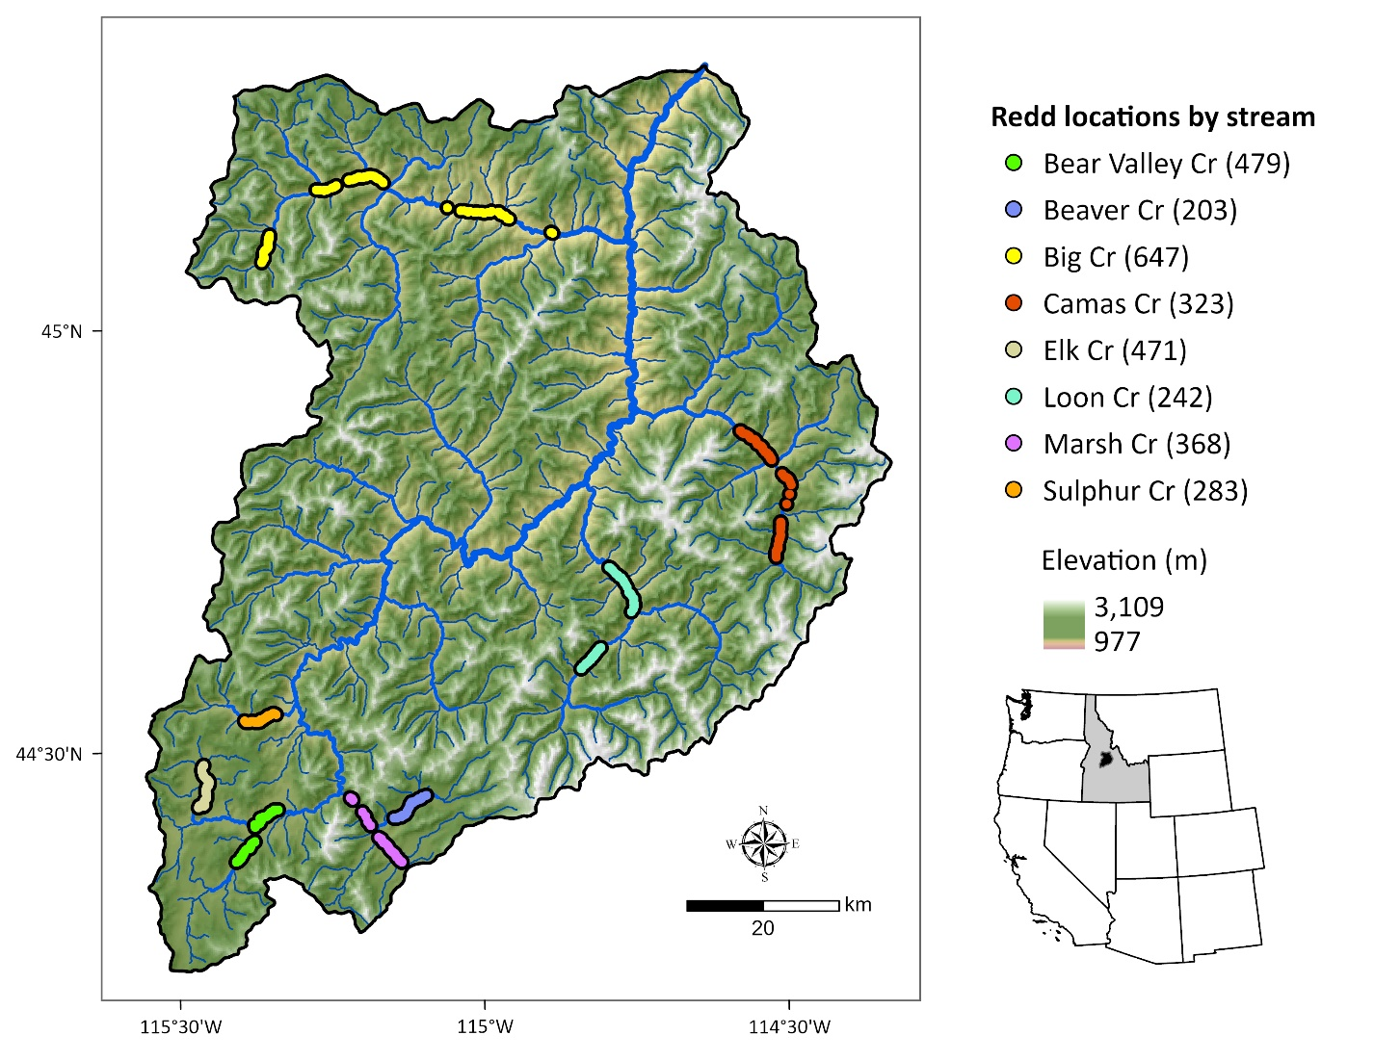Figure 1. Middle Fork Salmon River watershed illustrating major tributaries and locations of georeferenced Chinook Salmon redds from 2002 to 2005 (count of redds per stream given in parentheses). Point locations were dissolved for visualization.

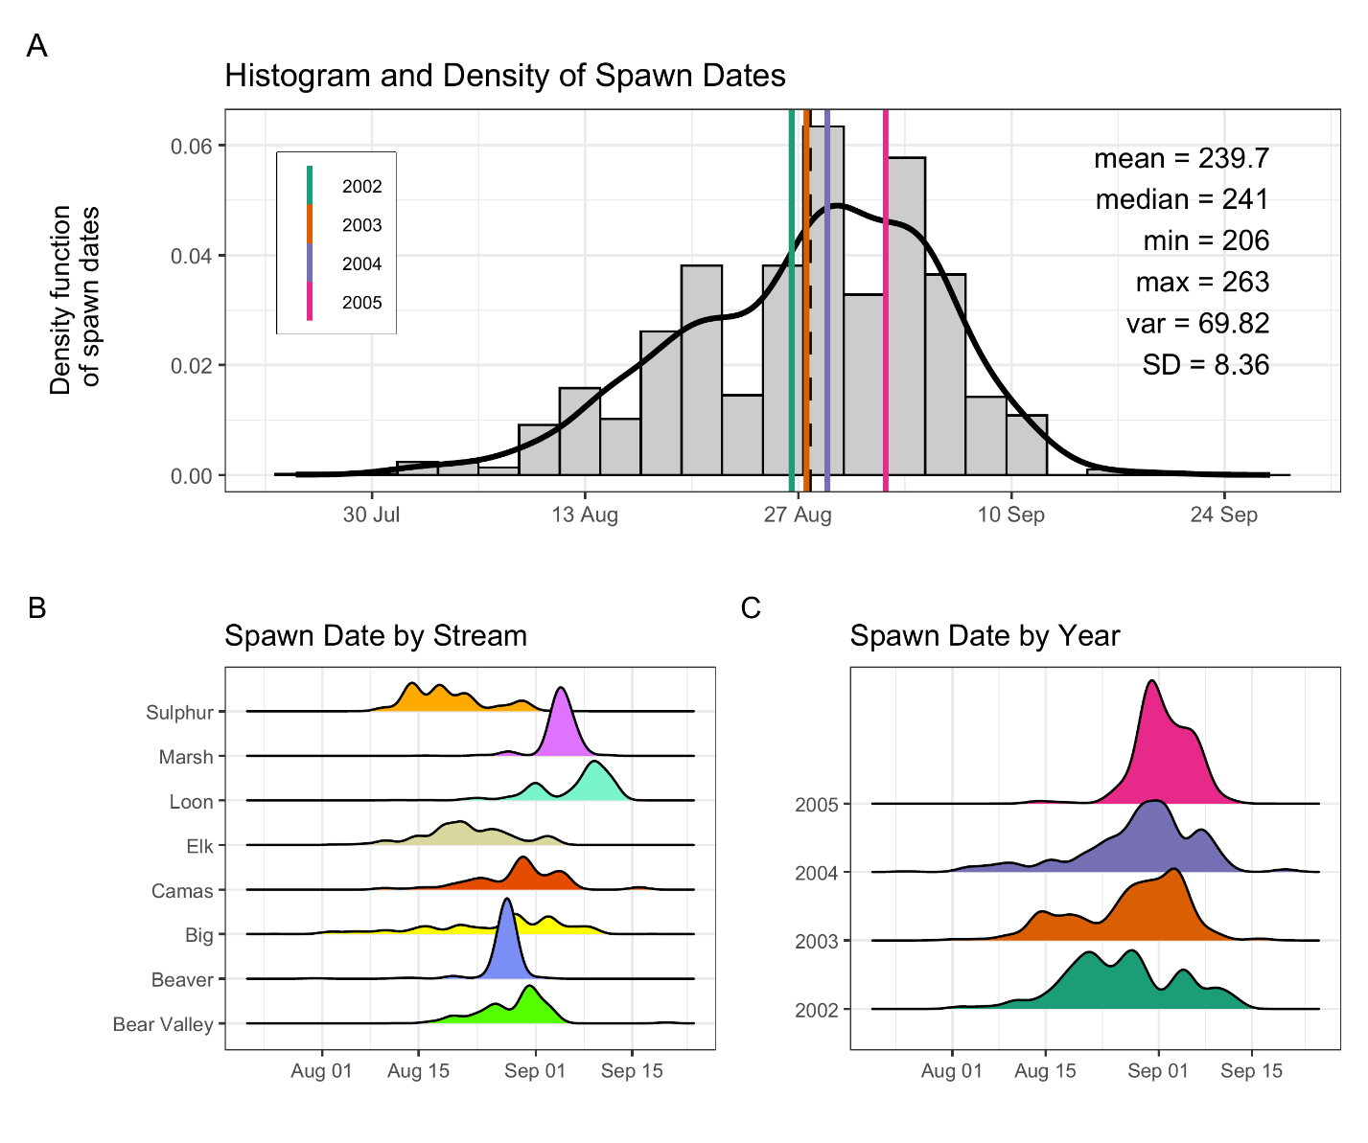

Figure 2: Histogram and density of Chinook salmon spawn timing across all streams and years (A), by stream (B), and by year (C). In panel (A), the histogram and kernel density illustrate the overall distribution of spawn dates; vertical-colored lines illustrate year-specific means, and the black line depicts the global mean. Spawn timing was generally unimodal, peaking in late August to early September.

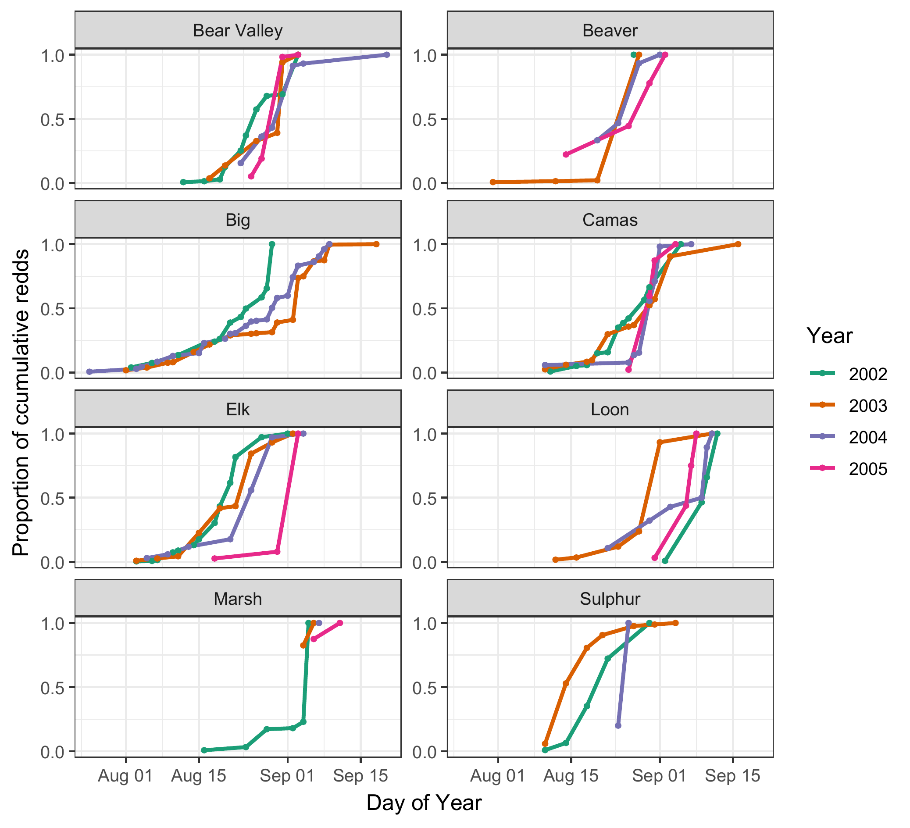

Figure 3. Proportion of cumulative Chinook salmon redds over time (day of year) across years (2002–2005) and streams. Each line represents a different year, with color denoting the year. Stream-specific panels illustrate temporal variation in the progression of spawning activity, as measured by cumulative redd counts normalized to the maximum value in each stream-year combination.

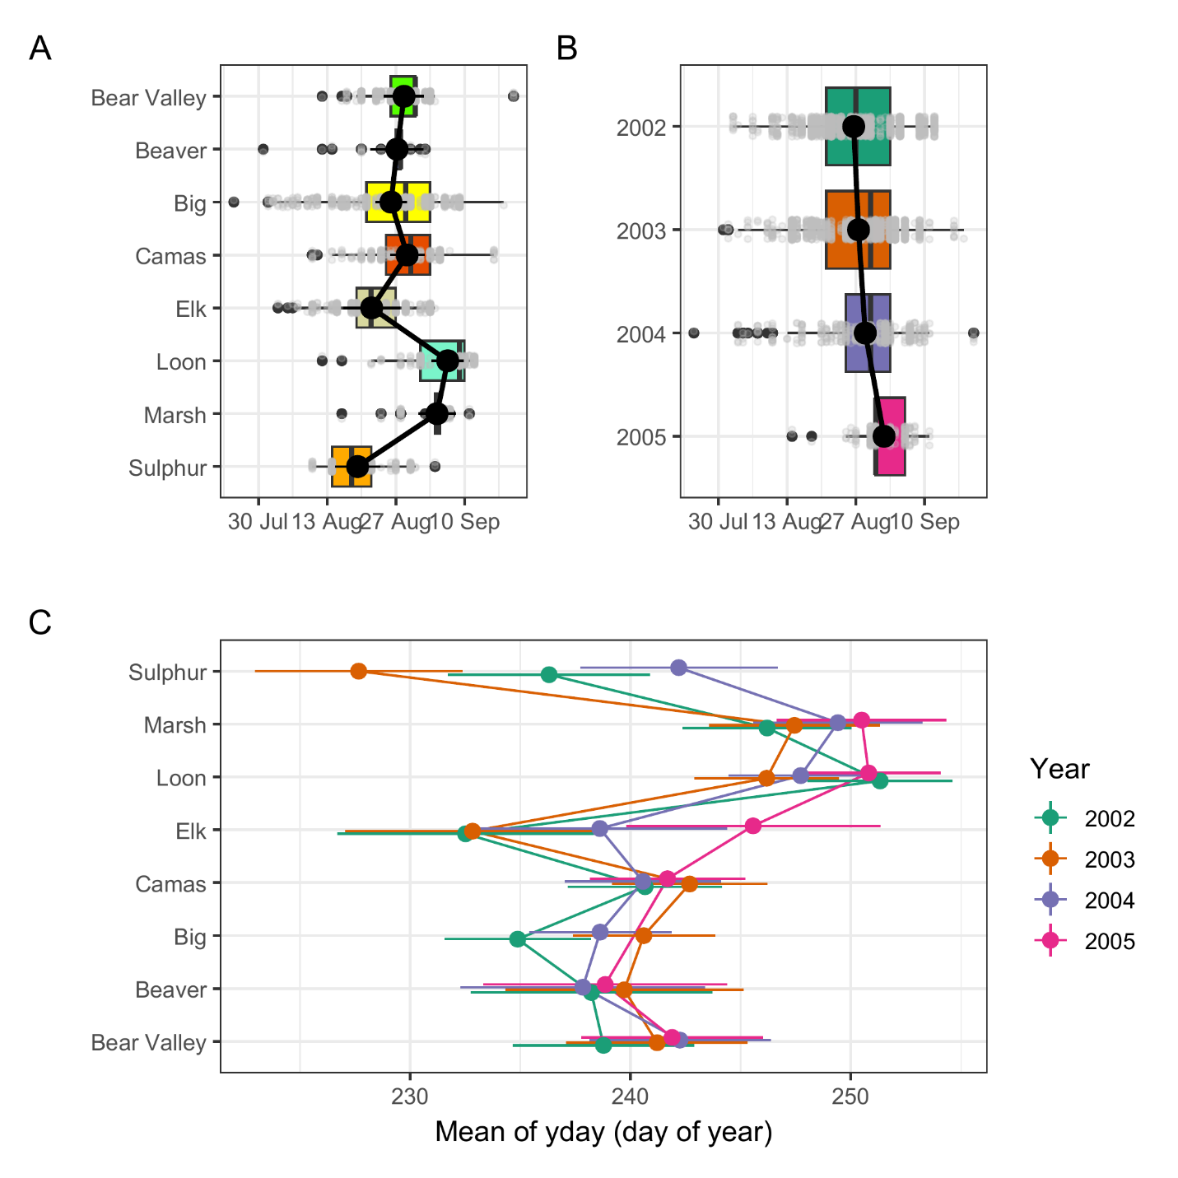

Figure 4. Predicted mean spawn dates by stream (A), year (B) and stream and year (C), from the final mixed-effects model. Black points with black lines (A, B), and colored points with horizontal lines (C) represent estimated marginal means and 95\\% confidence intervals. Boxplots in panels A and B show the distribution of observed redd counts by group, with individual data points in grey. The modeled predictions represent marginal means accounting for fixed effects and averaged over random effects.

Figure 5. Predicted relationship between spawn timing and 90-day pre-spawn mean temperature by stream and year. Lines represent model predictions from the final mixed-effects model. Colored points illustrate observed spawn timing, shaded ribbons represent 95% confidence intervals for predictions.

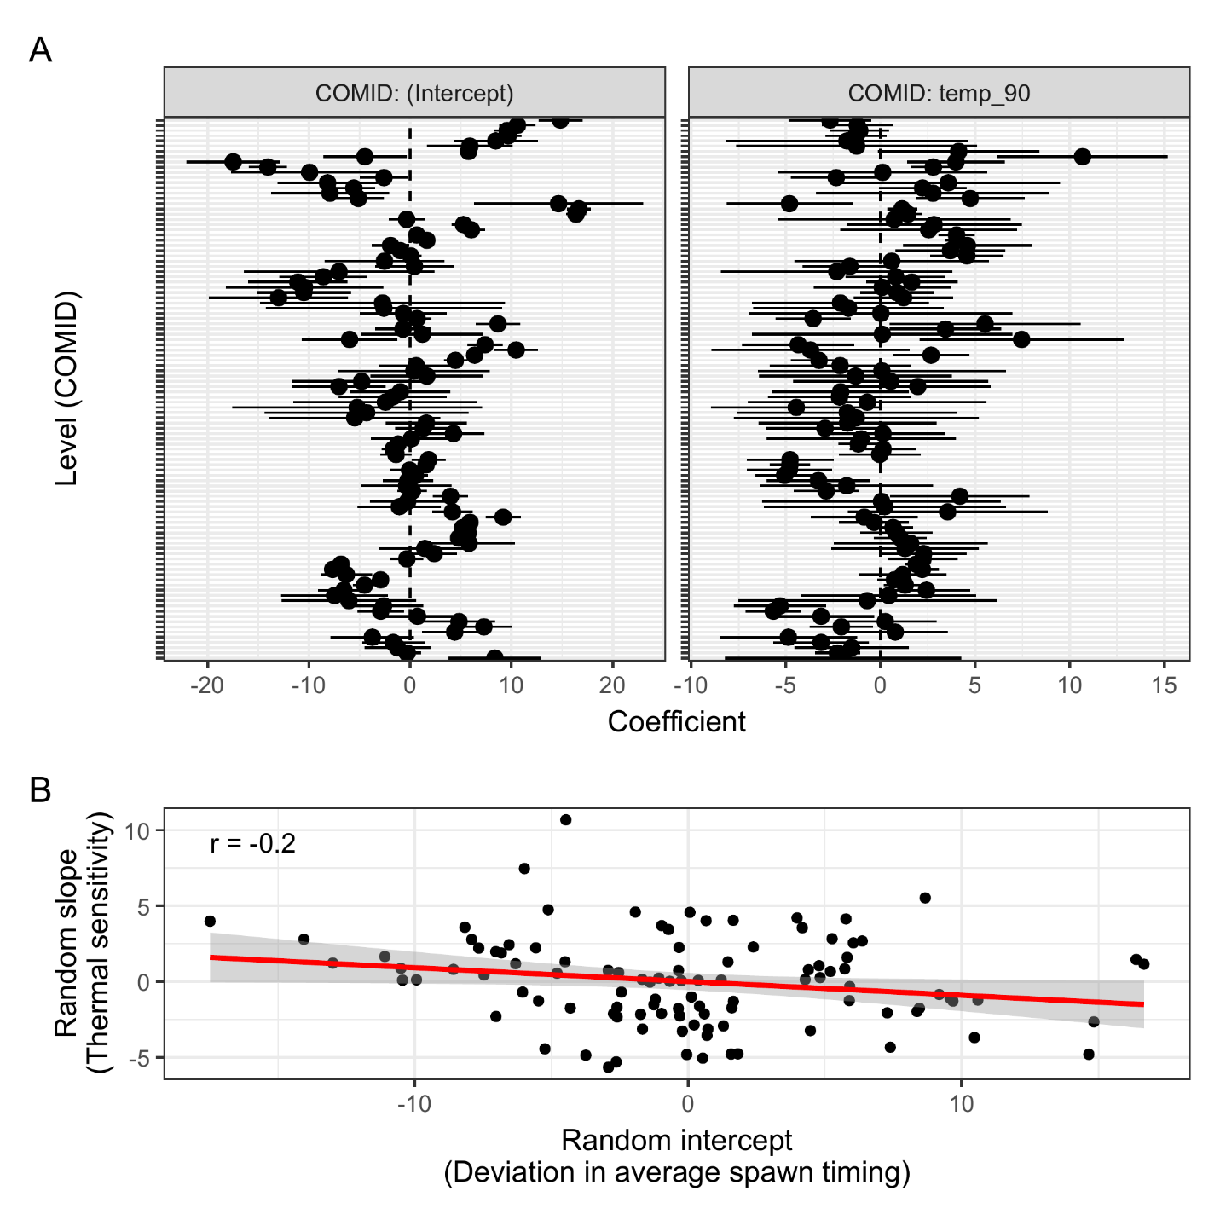

Figure 6: (A) COMID-specific random parameter estimates for intercepts (left) and slopes (right). Points represent best linear unbiased predictions (BLUPs) from the final model, with horizontal bars indicating ±1.96 standard errors. (B) Correlation between random intercepts and slopes for 90-day temperature across COMIDs. Each point represents a stream reach (COMID).

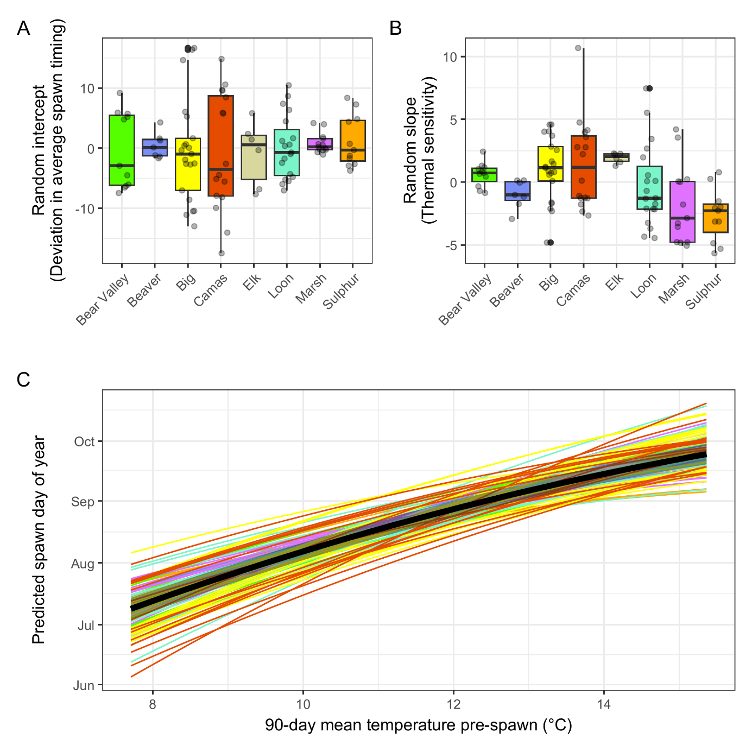

Figure 7. Variation in COMID- and stream-level thermal sensitivity and predicted spawn timing relationships. (A) Boxplots of random intercepts and slopes for 90-day pre-spawn temperature by stream. Each box represents the distribution of best linear unbiased predictions (BLUPs) for COMID-level intercepts (average spawn timing) or slopes (thermal sensitivity). (B) Predicted spawn timing by 90-day pre-spawn temperature and COMID. Each line represents the predicted relationship for a specific COMID, colored by stream. The black line and shaded ribbon denote the population-level mean and 95% confidence interval.